

**FACULTY OF SCIENCE & TECHNOLOGY**

**COMPUTER GRAPHICS**

**Spring 2023-24**

**Section: __G__**

**PEOJECT REPORT ON**

**“Space Sentinels: Asteroid Annihilation Chronicles”**

**Supervised by**

**MAHFUJUR RAHMAN**

**Lecturer, Computer Science**

**Submitted by:**

|  |  |  |
| --- | --- | --- |
| *Name* | *ID* | *Contribution* |
| Ashiqur Rahman Saron | **22-48697-3** | **20%** |
| Hasin Almas Sifat | **22-48679-3** | **20%** |
| Nabila Tabassum Borsha | **21-45289-2** | **20%** |
| Amit Hasan Ruhin | **21-44853-2** | **20%** |
| Mahmuda Akter Munni | **22-46495-1** | **20%** |

Submitted On: 14 May,2024

* **TITLE:**

**Space Sentinels: Asteroid Annihilation Chronicles**

* **INTRODUCTION:**

Welcome to the thrilling universe of “Space Sentinels: Asteroid Annihilation Chronicles”. In this adrenaline-pumping 2D game crafted with the power of C++ and OpenGL, players are thrust into the heart of an interstellar conflict where their skills as cosmic defenders will be put to the ultimate test. Piloting advanced space-fighting planes armed with powerful lasers, players must navigate through a treacherous asteroid field, using precision and agility to obliterate incoming threats and protect the galaxy from imminent destruction. With three challenging difficulty levels and the option for exhilarating multiplayer showdowns, ‘Space Sentinels’ promises an immersive gaming experience that will keep players on the edge of their seats. Prepare yourself for an immersive cosmic adventure, where danger, excitement, and the fate of the universe hang in the balance.

* **OBJECTIVE OF THE PROJECT:**

The aim of this project is to develop an engaging 2D game using C++ and OpenGL that merges the falling sand algorithm with space-fighting plane mechanics and particle systems, providing players with an immersive experience centered around asteroid destruction and survival. Our objectives include implementing the falling sand algorithm for realistic asteroid behavior, designing space-fighting plane mechanics such as movement, shooting lasers, and collision detection, integrating a scoring system based on asteroids destroyed, creating three difficulty levels, adding multiplayer functionality for competitive or cooperative play, optimizing game performance, enhancing visual appeal with high-quality graphics, animations, and special effects, conducting playtesting for feedback, and documenting the development process. Ultimately, we aim to deliver a polished and enjoyable game that exceeds player expectations and serves as a testament to our expertise in computer graphics and game development.

* **PROBLEM STATEMENT:**

Asteroid Annihilation Chronicles aims to address the need for a captivating and immersive gaming experience that combines elements of classic arcade-style gameplay with modern graphics and mechanics. While there are many space-themed games available, few offer the unique combination of realistic physics-based asteroid simulation, intuitive space-fighting plane mechanics, and multiplayer functionality. This project seeks to fill that gap by providing players with a thrilling adventure set in the vast expanse of space, where they must navigate through treacherous asteroid fields, engage in intense combat, and work together or compete against each other to save the galaxy from destruction.

* **BACKGROUND STUDY:**

The concept of space-themed games has been a popular genre in the gaming industry for decades, with titles ranging from classic arcade games like Asteroids to modern space exploration simulations like Elite Dangerous. These games often draw inspiration from real-world physics and space exploration concepts to create immersive experiences for players.

One of the key challenges in developing a space-themed game is creating realistic physics simulations for objects like asteroids. The falling sand algorithm, initially popularized in games like Powder Toy and Falling Sand Game, provides a compelling framework for simulating granular materials and can be adapted to simulate the behavior of asteroids in space environments. By implementing this algorithm, Space Sentinels: Asteroid Annihilation Chronicles aims to deliver a more realistic and dynamic gameplay experience, where asteroids interact with each other and the player's actions in a believable manner.

In addition to realistic physics simulations, engaging gameplay mechanics are essential for a successful gaming experience. Space-fighting plane mechanics, inspired by classic shoot 'em up games like Galaga and R-Type, offer players intuitive controls and responsive gameplay as they navigate through asteroid fields, dodge enemy attacks, and unleash powerful lasers to destroy threats. By combining these mechanics with the falling sand algorithm, Space Sentinels: Asteroid Annihilation Chronicles creates a unique blend of arcade-style action and realistic simulation, offering players a fresh and exciting gameplay experience.

Furthermore, multiplayer functionality adds another layer of depth and replayability to the game, allowing players to team up with friends or compete against each other in epic space battles. By implementing multiplayer features, Space Sentinels: Asteroid Annihilation Chronicles encourages social interaction and fosters a sense of camaraderie and competition among players, enhancing the overall gaming experience.

Overall, Space Sentinels: Asteroid Annihilation Chronicles builds upon the rich tradition of space-themed games while introducing innovative mechanics and features to create a truly immersive and engaging gaming experience. With its blend of realistic physics simulations, intuitive gameplay mechanics, and multiplayer functionality, this project aims to captivate players and transport them to the thrilling depths of space where danger and adventure await.

* **METHODOLOGY:**

The development of "Space Sentinels: Asteroid Annihilation Chronicles" involves a systematic approach that encompasses various stages, from conceptualization to implementation and testing. Below is an overview of the methodology and system implementation methods used in the creation of the game:

1. **Conceptualization and Planning:**
   * Define the game concept, including its core mechanics, theme, and target audience.
   * Conduct market research to identify existing games in the genre and gather inspiration for unique features.
   * Create a detailed game design document outlining the gameplay mechanics, level design, art style, and technical requirements.
2. **Technology Selection:**
   * Choose the appropriate technology stack for game development, considering factors such as platform compatibility, performance, and ease of use.
   * Select C++ as the primary programming language for its performance and flexibility.
   * Utilize OpenGL for rendering graphics, providing cross-platform support and access to hardware-accelerated graphics capabilities.
3. **Space-Fighting Plane Mechanics:**
   * Design and implement intuitive controls for the space-fighting plane, including movement, shooting, and collision detection.
   * Develop algorithms for enemy AI behavior, such as tracking and attacking the player.
   * Implement collision detection systems to handle interactions between the player's plane, asteroids, and enemy entities.
4. **Scoring System and Difficulty Levels:**
   * Design a scoring system based on the number of asteroids destroyed by the player.
   * Implement multiple difficulty levels with varying parameters such as asteroid density, speed, and enemy aggression.
   * Balance gameplay mechanics to provide a challenging yet fair experience across different difficulty settings.
5. **The Starfield Effect:**
   * **The starfield effect was implemented using the processing programming language, known for its simplicity and suitability for visual projects.**
   * <https://cs.brynmawr.edu/gxk2013/examples/transformations/starfield/>

1. **Optimization and Performance:**
   * Profile the game to identify performance bottlenecks and areas for optimization.
   * Optimize rendering pipelines, physics simulations, and networking code to ensure smooth gameplay across a range of hardware configurations.
   * Employ techniques such as object pooling, level-of-detail rendering, and asynchronous loading to minimize resource usage and improve frame rates.
2. **Visuals and Audio:**
   * Create high-quality graphics assets, including sprites, animations, and particle effects, to enhance visual appeal.
   * Design immersive sound effects and background music to complement the game's atmosphere and action.
   * Implement shaders and post-processing effects to enhance visual fidelity and create dynamic lighting and particle effects.
3. **Testing and Iteration:**
   * Conduct playtesting sessions with target audiences to gather feedback on gameplay mechanics, difficulty balancing, and overall satisfaction.
   * Iterate on the game design based on player feedback, making adjustments to improve user experience and address any issues or concerns.
   * Perform thorough QA testing to identify and fix bugs, ensuring a stable and polished final release.
4. **Documentation and Release:**
   * Document the development process, including design decisions, technical implementations, and any challenges encountered.
   * Prepare marketing materials and promotional assets to generate interest and anticipation for the game.
   * Coordinate with distribution platforms for the release of the game, ensuring compatibility and compliance with platform guidelines and requirements.

* **SIGNIFICANT OF THE PROJECT:**

The "Space Sentinels: Asteroid Annihilation Chronicles" project holds significant value in several key aspects:

1. **Entertainment and Engagement:** As a video game, its primary purpose is to entertain players and provide an engaging experience. By offering thrilling gameplay, immersive visuals, and challenging mechanics, the game aims to captivate players and keep them entertained for hours on end. This entertainment factor is significant as it contributes to the overall enjoyment and satisfaction of players, fostering positive experiences and building a loyal fan base.
2. **Innovation and Creativity:** The project aims to innovate within the space-themed gaming genre by blending elements of the falling sand algorithm with space-fighting plane mechanics and multiplayer functionality. This innovative approach sets the game apart from existing titles and offers players a fresh and unique gaming experience. By pushing the boundaries of creativity and experimentation, the project contributes to the evolution of gaming as an art form and medium of expression.
3. **Educational Value:** Beyond entertainment, the project has educational value by introducing players to concepts related to space, physics, and strategy. Through interactions with realistic simulations of asteroid behavior and space combat mechanics, players may gain insights into scientific principles and problem-solving skills. Additionally, the game's multiplayer functionality promotes collaboration, communication, and teamwork among players, fostering social and cognitive development.
4. **Technical Advancement:** The development of "Space Sentinels: Asteroid Annihilation Chronicles" involves the utilization of advanced technologies and programming techniques, including C++, OpenGL, and multiplayer networking. By leveraging these technologies, developers can showcase their technical expertise and push the boundaries of what is possible in game development. The project may also contribute to the advancement of gaming technology and serve as a learning resource for aspiring game developers.
5. **Community Building:** As a multiplayer game, "Space Sentinels: Asteroid Annihilation Chronicles" has the potential to build a strong community of players who share a common interest in space-themed gaming. The game provides a platform for players to connect, compete, and collaborate with each other, fostering a sense of belonging and camaraderie within the gaming community. This community-building aspect is significant as it promotes social interaction, friendship, and shared experiences among players from diverse backgrounds.

Overall, the "Space Sentinels: Asteroid Annihilation Chronicles" project holds significant value in terms of entertainment, innovation, education, technical advancement, and community building. By delivering an engaging and immersive gaming experience, the project enriches the lives of players and contributes to the broader cultural and technological landscape of the gaming industry.

* **SCREENSHOT OF THE SYSTEM:**

**FRONT PAGE:**

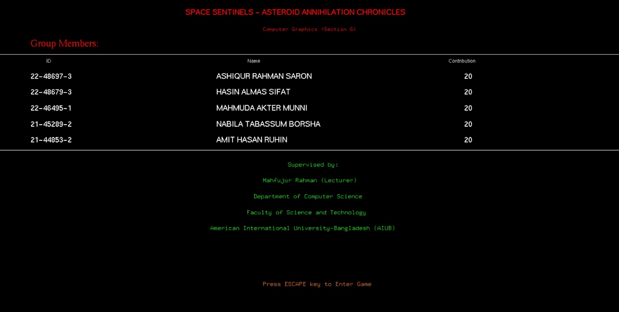

**HOME PAGE:**

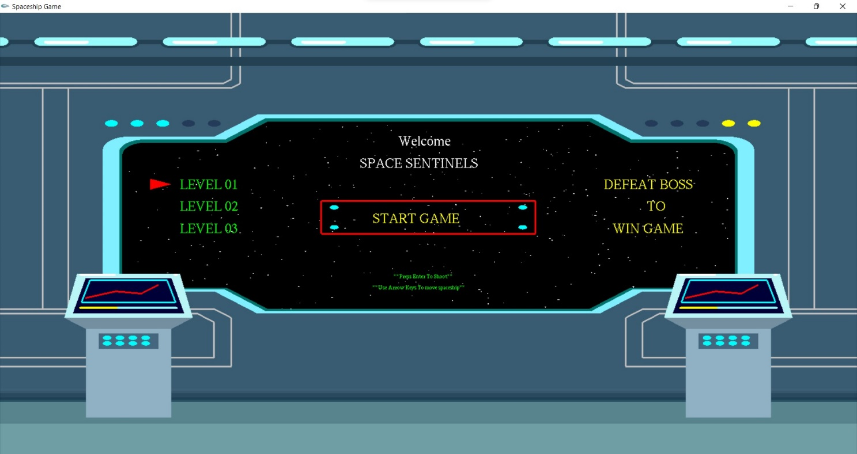

**LEVEL 1:**

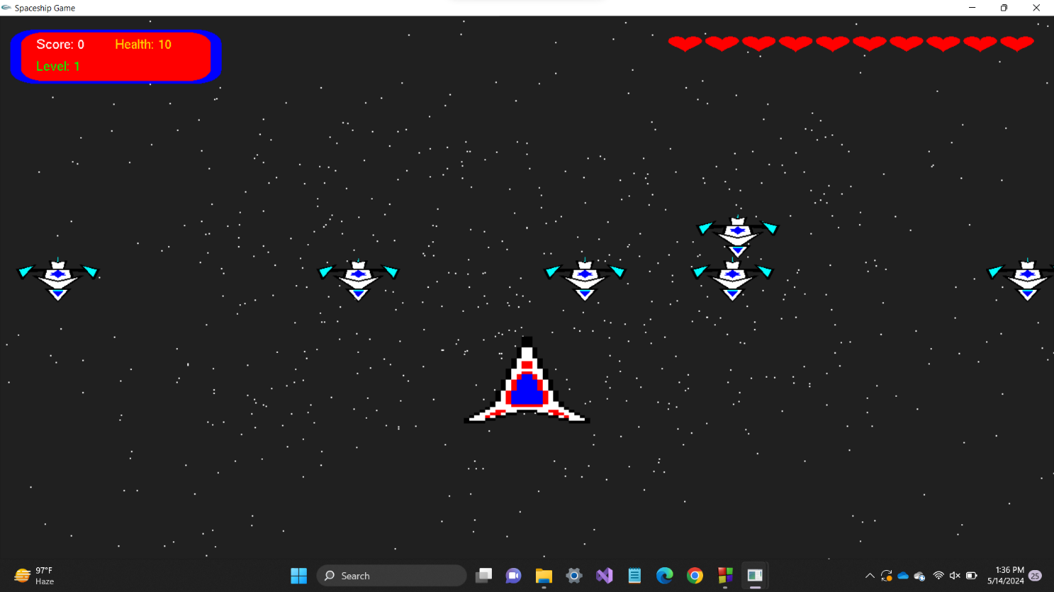

**LEVEL 2:**

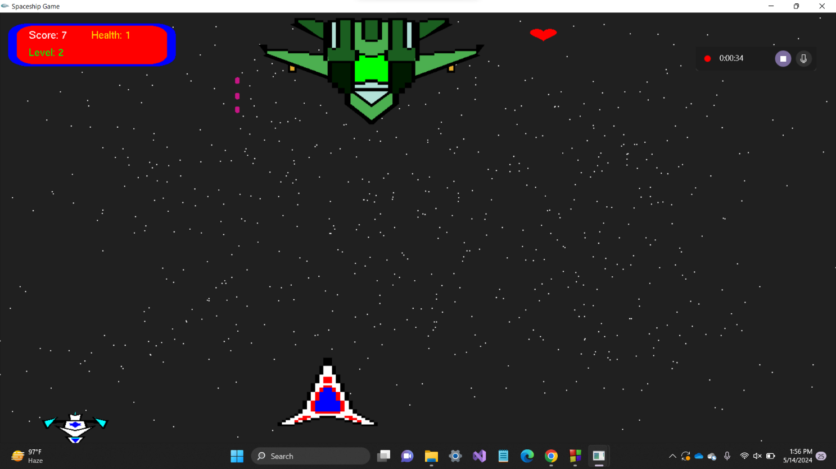

**LEVEL 3:**

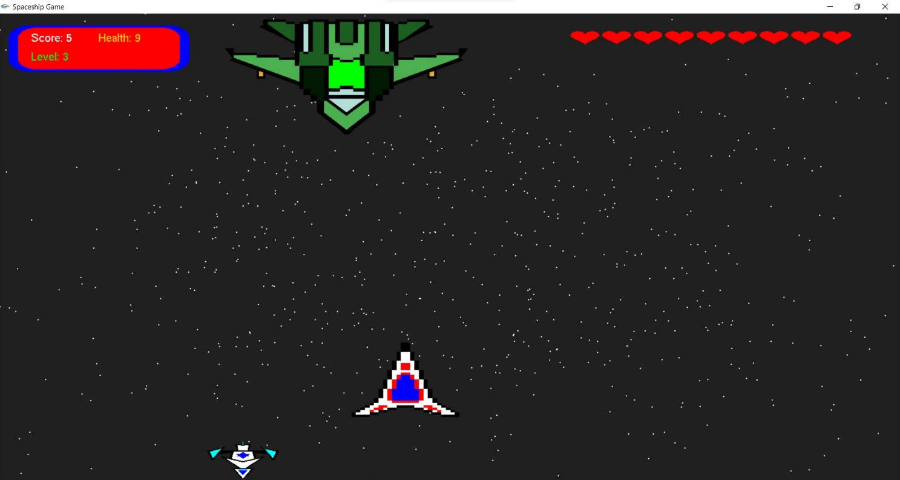

**GAME OVER:**

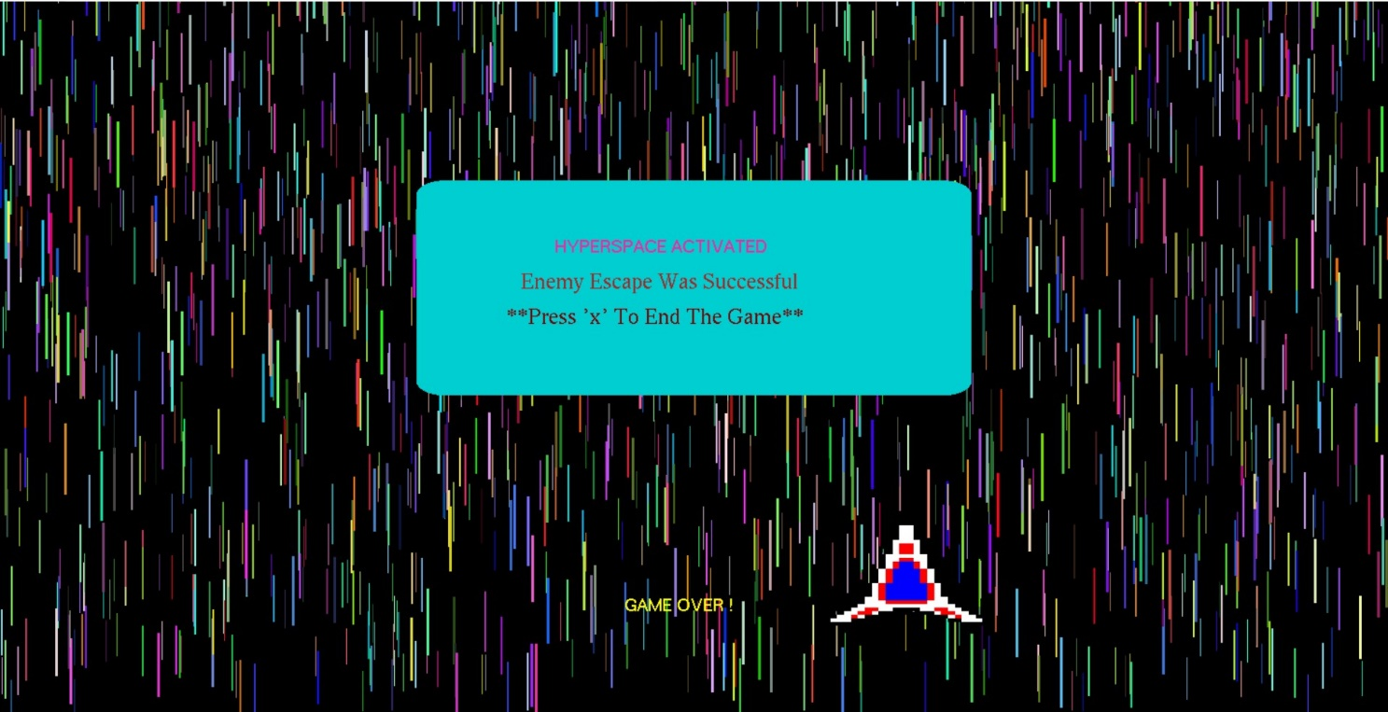

**ENDING PAGE:**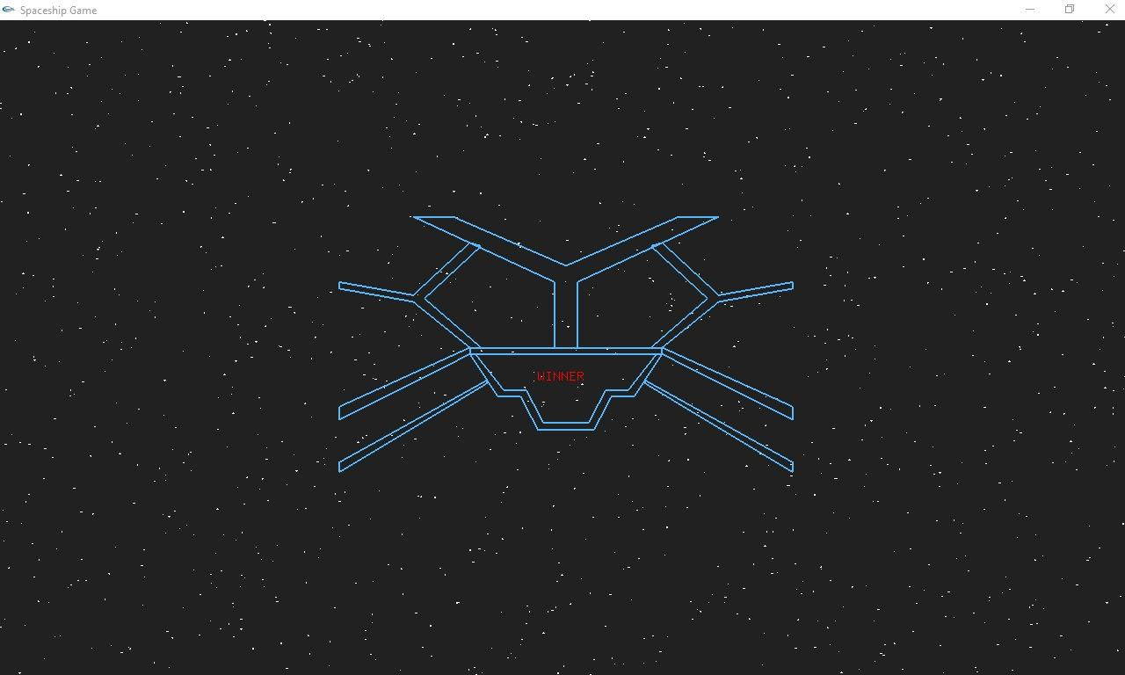

* **CONCLUSION:**

Space Sentinels: Asteroid Annihilation Chronicles" represents a significant endeavor that combines entertainment, innovation, education, technical advancement, and community building within the gaming industry. Through its thrilling gameplay, immersive visuals, and innovative mechanics, the game aims to captivate players and provide them with a unique and engaging experience set in the vast expanse of space.

By blending elements of the falling sand algorithm with space-fighting plane mechanics and multiplayer functionality, the project pushes the boundaries of creativity and technical expertise, contributing to the evolution of gaming as an art form and medium of expression. Moreover, the educational value of the game introduces players to scientific principles and fosters social and cognitive development through collaboration and teamwork.

Furthermore, the project has the potential to build a strong community of players who share a passion for space-themed gaming, fostering social interaction, friendship, and shared experiences. This sense of community not only enhances the gaming experience but also contributes to the broader cultural and technological landscape of the gaming industry.

In essence, "Space Sentinels: Asteroid Annihilation Chronicles" represents more than just a video game—it's a testament to the creativity, innovation, and passion of its developers and a source of enjoyment and inspiration for players around the world. With its captivating gameplay, immersive visuals, and engaging mechanics, the game promises to leave a lasting impact on the gaming community and the broader cultural zeitgeist.

* **REFERENCES:**
  + <http://youtu.be/-FozillV7No?si=89gt6hcBu2WRTLHn>
  + <https://cs.brynmawr.edu/gxk2013/examples/transformations/starfield/>
  + Project YOUTUBE Video Link:

<https://youtu.be/aTFRnHMR_R4>

* + Project GITHUB link:

<https://github.com/ashiqursaron/Space-Sentinels.git>